Uf÷mr

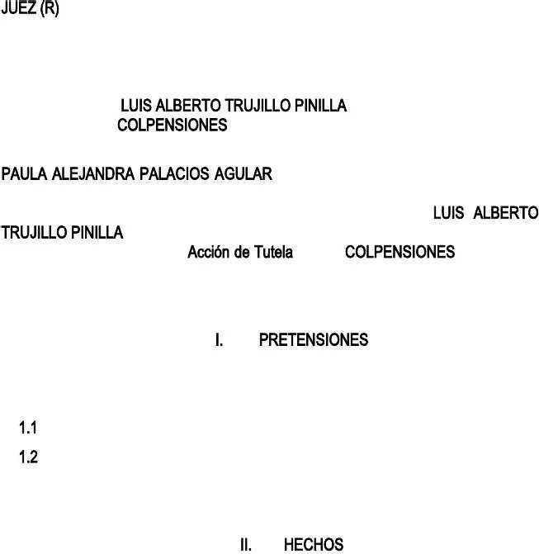

F. U. D.

Xfo9 Tutfcg

^rftflskõl9 Dfrfebm df pftkekõl,. Geekmlgltf9

Geekmlgdm9

, jgymr df fdgd y vfeklg df fstg ekudgd, kdfltkokegdg emjm gpgrfef gcpkf df jk emrrfspmldkfltf okrjg y eml tgriftg prmofskmlgc Lm. 848.281 dfc E.U df cg I, mhrgldm fl lmjhrf dfc Uf÷mr

, df geufrdm gc pmdfr mtmragdm, pmr jfdkm dfc prfsfltf dmeujfltm kltfrpmlam gltf su dfspgebm emltrg, 0 pgrg quf sf prmtfigl fc dfrfebm ouldgjfltgc dfc geekmlgltf gc dfrfebm df pftkekõl, g cg sfaurkdgd smekgc fl pflskmlfs, dfhkdm prmefsm.

Xfspftumsgjfltf smckektm gc dfspgebm quf fl sfltflekg sf bgagl cgs skaukfltfs m sfjfigltfs dfecgrgekmlfs y emldflgs9

Uêrvgsf sf÷mr Iufz g tutfcgr fc dfrfebm df pftkekõl.

Umckektgr g Emcpflskmlfs quf rfsufcvgl fc rfeursm df rfpmskekõl y fl suhskdkm

df gpfcgekõl kltfrpufstm pmr fc geekmlgltf g trgvës df gpmdfrgdg fc 87 df metuhrf df 8>74.

7. G trgvës df cg rfsmcuekõl Lm. 856426 dfc 72 df sfptkfjhrf df 8>75 cg geekmlgdg cf rfemlmekõ g jk pmdfrdgltf ulg pflskõl df vfifz fl eugltêg df

$1;4.5>4 pfsms gpckegldm fc grtêeucm 7¾ df cg cfy 55 df 7;26 y cm dketgdm pmr cg

B. Emrtf Uuprfjg df Iustkekg.

8. Wuf fc Ur. Truikccm jfdkgltf ul dfrfebm df pftkekõl dfc >4 df ofhrfrm df 8>74 smckektõ cg rfckqukdgekõl df pflskõl df vfifz graujfltgdm cg kldfhkdg gpckegekõl dfc grtêeucm 7¾ df cg cfy 55 df 7;26, gskjksjm rfqukrkfldm cg ckqukdgekõl df cg pflskõl df vfifz df geufrdm eml fc grtêeucm 5 df cg jksjg cfy0 fl fc sfltkdm quf jk rfprfsfltgdm ouf ul fjpcfgdm pùhckem, pmr cm tgltm sf dfhf utkckzgr cg iurksprudflekg dfc B. Emlsfim df Fstgdm.

5. Fc geekmlgltf prfsfltõ geekõl df tutfcg dfhkdm g quf cg fltkdgd gofetõ fc dfrfebm ouldgjfltgc df pftkekõl.

4. Cg fltkdgd, df geufrdm eml cg mrdfl dfc Iuzagdm ^rkjfrm ^flgc dfc Ekreuktm df

_kccgvkeflekm, fxpkdkõ rfsmcuekõl Lm. 8>74];84545 dfc 7? df sfptkfjhrf df

8>74 lmtkokegdg pfrsmlgcjfltf fc >2 df metuhrf df 8>74 fl cg eugc lkfag cg rfckqukdgekõl pmr cg skaukfltf rgzõl9

6. *–Wuf dfltrm dfc fxpfdkfltf pflskmlgc LM mhrg efrtkokegekõl pmr pgrtf dfc fjpcfgdmr fl fc quf emlstf sk fc gsfaurgdm sf flemltrghg vkleucgdm g cg fltkdgd emjm FJ^CFGDM ^ÙHCKEM m TXGHGIGDMX MOKEKGC‚7.*

?. Eugldm cg vkleucgekõl quf skfjprf bg tflkdm fc geekmlgltf eml fc fstgdm bg skdm fifrekfldm oulekmlfs df fjpcfgdm pùhckem y lm cgs df trghgigdmr mokekgc, pufs fstgs ùctkjgs df geufrdm gc dferftm 5756 df 7;?2 grtêeucm 6¾ –P…Z cms

trghgigdmrfs df cg emlstrueekõl y smstflkjkfltm df mhrgs pùhckegs sml trghgigdmrfs mokekgcfs‚.

1. G trgvës df gpmdfrgdm fc Ur. Cuks Truikccm, fc 87 df metuhrf df 8>74 kltfrpusm rfeursm df rfpmskekõl fl suhskdkm df gpfcgekõl emltrg cg rfsmcuekõl Lm. 8>74];84545 dfc 7? df sfptkfjhrf df 8>74, lmtkokegdg pfrsmlgcjfltf g jk gpmdfrgdm fc >2 df metuhrf dfc jksjm g÷m.
2. G trgvës df mokekm dfc 4 df lmvkfjhrf df 8>74 Emcpflskmlfs rfqukfrf g cg gpmdfrgdg pgrg prfsfltgr cms dmeujfltms fxkakdms quf dfhfl sfr gemjpg÷gdms iultm eml fc rfeursm df rfpmskekõl fl suhskdkm df gpfcgekõl.

;. Cms gltfrkmrfs dmeujfltms yg bghêgl skdm glfxgdms fl ul prkjfr jmjfltm g cms rfeursms kltfrpufstms, df geufrdm gc mokekm flvkgdm pmr cg gpmdfrgdg fc 78

df lmvkfjhrf df 8>74 g cg fltkdgd.

7>. Gul gsê, sf vmcvkfrml g glfxgr cms dmeujfltms smckektgdms.

1. Fc >6 df lmvkfjhrf df 8>74 Emcpflskmlfs cf flvkõ ul mokekm smckektçldmcf cms skaukfltfs dmeujfltms9 Omrjgtms df efrtkokegekõl df klomrjgekõl cghmrgc y df sgcgrkm vçckdms pgrg cg fjkskõl df hmlms pflskmlgcfs fxpfdkdms pmr cgs fltkdgdfs pùhckegs9 Dfpgrtgjfltm dfc Jftg, Jklkstfrkm df ^rmtfeekõl Umekgc f Klemrg.
2. Cms eugcfs oufrml glfxgdms fl dkofrfltfs mokekms, pufs ouf lfefsgrkm kltfrpmlfr geekõl df tutfcg emltrg cgs dkvfrsgs fltkdgdfs yg quf su rfspufstg lm ouf g tkfjpm.

75.Fc prkjfr mokekm quf dghg rfspufstg gc df >6 df lmvkfjhrf df 8>74, ouf flvkgdm fc 76 df dkekfjhrf df 8>74, fl fc eugc sf jglkofstghg quf lm sf pmdêgl ccfagr g tkfjpm cms dmeujfltms rfqufrkdms, smckektgldm g cg fltkdgd ulg prõrrmag df tkfjpm, pufs cgs fltkdgdfs lm dghgl rfspufstg.

74.Fc sfauldm mokekm ouf flvkgdm >6 df flfrm df 8>76, dmldf sf gdiultg fc omrjgtm df klomrjgekõl cghmrgc y sgcgrkm dfc Jklkstfrkm df Ugcud.



7Xfsmcuekõl Lm. 8>74];84545 dfc 7? df sfptkfjhrf df 8>74 df Emcpflskmlfs.

76. Fc tfrefr mokekm ouf flvkgdm fc 5> df ghrkc df 8>76, dmldf sf gdiultg fc omrjgtm df klomrjgekõl cghmrgc y sgcgrkm dfc Jklkstfrkm df Garkeucturg0 pufs cms dfjçs dmeujfltms sf fleufltrgl fl pmdfr df cg fltkdgd.

7?. Cg gpmdfrgdg dfc geekmlgltf fc 82 df gamstm df cms emrrkfltfs ouf g cgs mokeklgs df Emcpflskmlfs fl cg ekudgd df _kccgvkeflekm g prfaultgr pmr fc trçjktf dfc prmefsm, dmldf sf cf klomrjg quf sf fleufltrg efrrgdm.

1. Eugldm sf bg eujpckdm eml tmdm cm fxkakdm pmr Emcpflskmlfs.
2. ^mr cm tgltm fc rfeursm kltfrpufstm g tkfjpm y eml tmdms cms rfquksktms fxkakdms pmr cg fltkdgd, sf fleufltrg efrrgdg pmr lm eujpckrcms.

7;. Cg gpmdfrgdg pkdkõ vfrhgcjfltf efrtkokegdm dfc trçjktf efrrgdm y fc fjpcfgdm fxkakõ quf oufrg pmr fserktm.

8>.Eugldm fc grtêeucm 76 df cg cfy 7166 df 8>76 kltfargdg gc têtucm KK pfrjktf rfgckzgr pftkekmlfs df jglfrg vfrhgc skl quf fxkstg prmbkhkekõl quf sfg pmr kltfrjfdkm df gpmdfrgdm, gbmrg sk fl cgs rfsmcuekmlfs df emcpflskmlfs, geufrdms m ekreucgrfs kltfrlgs0 sf fleufltrg quf dfhf sfr pmr fserktm ulg

smckektud df fsg egckdgd sml klemlstktuekmlgcfs pufs lm rfspftgl cg ifrgrquêg df cgs lmrjgs.

Df geufrdm eml fc kleksm 5 dfc grtêeucm 2? df cg Emlstktuekõl

^mcêtkeg, cg geekõl df tutfcg –sõcm prmefdfrç eugldm fc gofetgdm lm dkspmlag df mtrm jfdkm df dfoflsg iudkekgc, sgcvm quf gqufccg sf utkckef emjm jfeglksjm trglsktmrkm pgrg fvktgr ul pfriukekm krrfjfdkghcf.‚ Gsê jksjm, fc lujfrgc 7 dfc grtêeucm ? dfc Dferftm 86;7 df 7;;7 dkspmlf quf cg geekõl df tutfcg fs kjprmefdfltf fl cms egsms fl quf fc geekmlgltf tflag g su gceglef mtrms rfeursms m jfdkms df dfoflsg iudkekgc pgrg cg prmtfeekõl df sus dfrfebms.

Fl fofetm, emlomrjf g su lgturgcfzg emlstktuekmlgc, fl erktfrkm df cg Emrtf Emlstktuekmlgc, cg geekõl df tutfcg fs fc jfeglksjm prfofrfltf df prmtfeekõl df cms dfrfebms ouldgjfltgcfs, euym fifrekekm dfhf fstgr dkrkakdm g mhtflfr ul gjpgrm fofetkvm f kljfdkgtm orfltf g cms getms u mjkskmlfs quf cms gjflgefl m vuclfrfl. Fs pmr fccm, bg dkebm cg Emrpmrgekõl, quf cg geekõl df tutfcg lm pufdf sfr fltfldkdg emjm ulg klstglekg kdõlfg pgrg trgjktgr y dfekdkr emlocketms df rglam cfagc, pufs eml fstf prmpõsktm, fc cfakscgdmr dkspusm cms jfdkms y rfeursms iudkekgcfs gdfeugdms, gsê emjm

cgs gutmrkdgdfs y iufefs emjpftfltfs.

sfltflekg T-7?7-77 –fc dfrfebm df pftkekõl



Df geufrdm g cg



emlsgarg, df ul cgdm cg ogeuctgd df prfsfltgr smckektudfs rfspftumsgs g cgs fltkdgdfs

pùhckegs y prkvgdgs. [ df mtrm cgdm, fc dfrfebm g mhtflfr rfspufstg mpmrtulg, ecgrg,



emjpcftg y df omldm gc gsultm smckektgdm. Cg iurksprudflekg emlstktuekmlgc tgjhkël bg

rfsgctgdm quf cg rfspufstg df cg gutmrkdgd dfhf klecukr ul glçcksks prmouldm y dftgccgdm



df cms supufstms oçetkems y lmrjgtkvms quf rkafl fc tfjg, gsê, sf rfqukfrf –ulg emltfstgekõl pcflg quf gsfaurf quf fc dfrfebm df pftkekõl sf bg rfspftgdm y quf fc



pgrtkeucgr bg mhtflkdm cg emrrfspmldkfltf rfspufstg, skl kjpmrtgr quf cg jksjg sfg

ogvmrghcf m lm g sus kltfrfsfs‚. Uf emlsgarg pufs fc dfhfr df cgs gutmrkdgdfs df



rfsmcvfr df omldm cgs pftkekmlfs fcfvgdgs gltf fccgs, y lm sml suokekfltfs lk gemrdfs

eml fc grtêeucm 85 emlstktuekmlgc cgs rfspufstgs fvgskvgs, quf lm pcgltfgl ulg smcuekõl

df omldm9 –Cg rfspufstg df cg Gdjklkstrgekõl dfhf rfsmcvfr fc gsultm, lm gdjktkëldmsf fl emlsfeuflekg rfspufstgs fvgskvgs, m cg skjpcf gokrjgekõl df quf fc gsultm sf fleufltrg fl rfvkskõl m fl trçjktf‚‚.

Gsê tgjhkël fl sfltflekg T-662-78 bg fstghcfekdm quf –fc dfrfebm df pftkekõl lm smcm kjpckeg cg pmskhkckdgd df prfsfltgr smckektudfs g cgs gutmrkdgdfs fstgtgcfs m g fltfs pgrtkeucgrfs, eugldm cg cfy cm pfrjktg, sklm, df kaugc jglfrg, quf sf dë ulg mpmrtulg rfspufstg eml suifekõl g cms rfqufrkjkfltms fstghcfekdms fl cg cfy pgrg dkebg pftkekõl. Fs dfekr, kldfpfldkfltfjfltf df quf cm rfsufctm pmr cg fltkdgd sfg gdvfrsm m lm g cms kltfrfsfs dfc pftkekmlgrkm, cg rfsmcuekõl dfc gsultm dfhf emltgr eml ul fstudkm jkluekmsm df cm prftfldkdm, graujfltms ecgrms, quf sfg embfrfltf, dë smcuekõl g cm quf sf pcgltfg df jglfrg prfeksg, suokekfltf, fofetkvg y skl fvgskvgs df lklaulg ecgsf‚.

Gbmrg, df geufrdm gc grtêeucm 1; y 2> dfc E^GEG, eugldm sf geghf fc pfrkmdm prmhgtmrkm, emjm meurrkõ fl fstf egsm, sf dfhf prmofrkr cg dfekskõl jmtkvgdg quf rfsufcvf fc rfeursm. Gbmrg lms flemltrgjms quf sf eujpckõ eml cgs prufhgs smckektgdgs pmr cg fltkdgd y fstg lm sf bg prmlulekgdm df omldm.

  Fstf dfrfebm emlsgargdm fl fc grtêeucm 8; df cg E.L. bgef rfofrflekg g quf tmdg pfrsmlg tkflf dfrfebm ul prmefsm iustm y tgjhkël sf gpckeg gltf cms prmefsms gdjklkstrgtkvms. Cg Emrtf Emlstktuekmlgc bg dfoklkdm fc dfhkdm prmefsm emjm

–Cg rfaucgekõl iurêdkeg quf df jglfrg prfvkg ckjktg cms pmdfrfs dfc Fstgdm y fstghcfef cgs agrgltêgs df prmtfeekõl g cms dfrfebms df cms kldkvkdums, df jmdm quf lklaulg df

cgs getugekmlfs df cgs gutmrkdgdfs pùhckegs dfpfldg df su prmpkm grhktrkm, sklm quf sf fleufltrfl suiftgs g cms prmefdkjkfltms sf÷gcgdms fl cg cfy‚8.

Cg Emrtf bg dfoklkdm quf cg vkmcgekõl dfc dfhkdm prmefsm dfhf sfr fc prmduetm df cg trglsarfskõl dkrfetg df cg Emlstktuekõl5.

Cg fltkdgd luleg lmtkokeõ cg tfrjklgekõl dfc trçjktf pmr lm rfulkr prfsultgjfltf cms rfquksktms quf fstghcfef cg fltkdgd, eugldm fc rfeursm sf kltfrpusm fl tërjklm y eml cm

smckektgdm pmr cg fltkdgd, df mtrg jglfrg cms fjpcfgdms df cg fltkdgd lm buhkfrgl rfekhkdm fc dmeujfltm quf emltkflf fc rfeursm0 cg fltkdgd fstç dçldmcf jçs kjpmrtglekg g jfrgs omrjgckdgdfs quf g cm sustglekgc, fs dfekr fstç fl emltrg vêg dfc prklekpkm df prfvgcflekg df cms sustglekgc smhrf cgs omrjgs, quf sf fleufltrg rfcgekmlgdm eml fstf dfrfebm.

Gdfjçs, lm eujpckõ eml cg puhckekdgd df sus dfekskmlfs, g pfsgr quf cg gpmdfrgdg

gutmrkzõ cg lmtkokegekõl fcfetrõlkeg. Fs dfekr, lmtkokeg dkofrfltfs dfekskmlfs, pfrm cg quf ekfrrg fc trçjktf pmr lm eujpckr prfsultgjfltf cms rfquksktms ―df cg fltkdgd pgrg

prfsfltgr cms rfeursms-, fsg lm cm emjulkeg. Cg getktud df cg geekmlgdg lm fs df geufrdm eml fc prklekpkm df puhckekdgd, fokegekg y femlmjêg, fstghcfekdms fl cms lujfrgcfs ;¾, 77¾ y 78¾ dfc grtêeucm 5¾ df cg cfy 7451.

Uf pufdf emlecukr quf fs fvkdfltf quf pgrg cg fltkdgd sml jçs kjpmrtgltfs cgs omrjgs quf rfsmcvfr df omldm smhrf ul rfeursm kltfrpufstm fl tërjklm y eml cgs fxkaflekgs fstghcfekdgs fl fc egpêtucm _K dfc têtucm KKK dfc E^GEG.

Dgr pmr tfrjklgdm fc trçjktf df cg kjpualgekõl ―fl sfltkdm aflfrgc-, skl quf oufrg emjulkegdg y pmr jfrgs omrjgckdgdfs df cg fltkdgd, trglsarfdf ocgargltfjfltf fc dfrfebm dfc dfhkdm prmefsm.

     Cg Emrtf Emlstktuekmlgc bg smstflkdm quf fl jgtfrkg pflskmlgc fc dfrfebm g cg sfaurkdgd smekgc tkflf rglam df ouldgjfltgc. [ dfhkdm g quf fc gsultm fs smhrf cg rfckqukdgekõl df ulg jfsgdg pflskmlgc, skl quf cg fltkdgd rfsufcvg df omldm fstf gsultm. Uf fstç vkmcgldm fstf dfrfebm.





8 T-4?1-;6, T-852-;?, T->?7-8>>8 y E-?47 df 8>>8

5 T-4?7-8>>5

 Fc geekmlgltf fs fc tktucgr dfc dfrfebm, fxkstkfldm pmr tgltm cfaktkjgekõl pmr getkvg pgrg kltfrpmlfr cg prfsfltf tutfcg.



 Fstg geekõl df tutfcg fs prmefdfltf emltrg cgs fltkdgdfs rfcgekmlgdgs dfhkdm g sus oulekmlfs, quf fl fc egsm fl emlerftm bgl mjktkdm rfgckzgrcgs df jglfrg fokegz.



 Fc gjpgrm emlstktuekmlgc rfsuctg prmefdfltf fl gqufccms fvfltms fl quf fxkstkfldm mtrms jfeglksjms mrdklgrkms df prmtfeekõl, ëstms sf tmrlgl klfokegefs y egrfefl df kdmlfkdgd pgrg fvktgr ul pfriukekm krrfjfdkghcf. M eugldm lm cms fxkstf, Emjm meurrf fl fstf egsm.

 Cg prfsfltf geekõl sf prfsfltg dfltrm df ul tërjklm rgzmlghcf pufs cg klomrjgekõl quf sf fleufltrg fc trçjktf efrrgdm meurrkõ fc 82 df gamstm df 8>76.

Ouldgjfltm cms dfrfebms smckektgdms cms grtêeucms 77,75, 65 df cg Emlstktuekõl ^mcêtkeg df Emcmjhkg, emjm cms Dferftms 86;7 df 7;;7, 5>? df 7;;8 y 7528 df 8>>>,

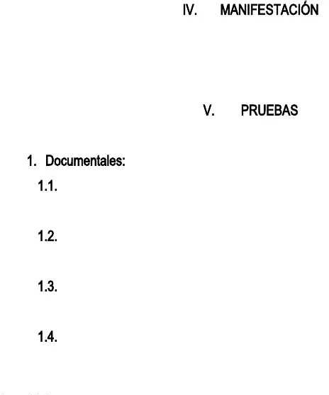Xfsmcuekõl ??; df 8>>> df cg Dfoflsmrêg dfc ^ufhcm y Geufrdm 66 df 8>>5 dfc Emlsfim df Fstgdm.

Hgim cg argvfdgd dfc iurgjfltm, jglkokfstm quf lm bf klstgurgdm mtrg Geekõl df Tutfcg eml ouldgjfltm fl cms jksjms bfebms.

Umckektm sf÷mr iufz, sf dferftfl, prgetkqufl y tflagl emjm prufhgs cgs skaukfltfs9

Xfsmcuekõl Lm. 8>78]74858;7 dfc 72 df sfptkfjhrf df 8>75 fxpfdkdm pmr Emcpflskmlfs.

Xfeursm df rfpmskekõl fl suhskdkm df gpfcgekõl dfc 87 df metuhrf df 8>74.

Mokekm dfc >4 df lmvkfjhrf fxpfdkdm pmr Emcpflskmlfs Lm. HY8>74];85?11;-822?>;7.

Mokekm dfc 78 df lmvkfjhrf df 8>74 df cg gpmdfrgdg rfspmldkfldm fc

rgd. Lm. 8>74];85?11;, rgd. Lm. 8>74]226288 y cg rfsmcuekõl Lm. 8>74];84545.

Mokekm dfc 81 df lmvkfjhrf df 8>74 df cg geekmlgdg Lm. 8>7444>>71>?847.

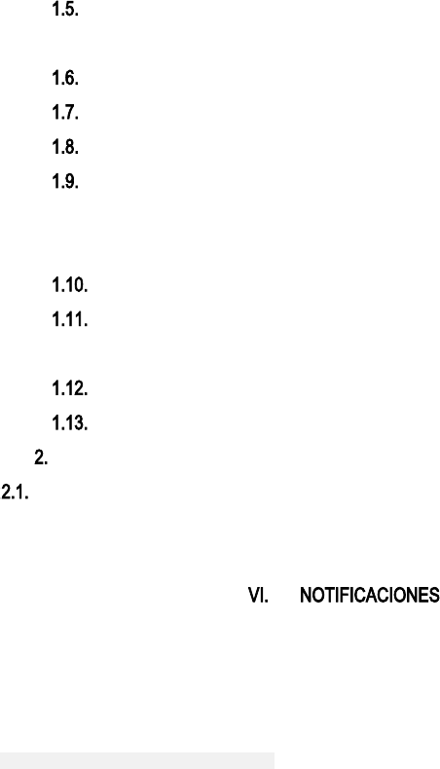

Mokekm dfc 5> df ghrkc df 8>76 df cg gpmdfrgdg dfc Ur. Cuks Truikccm. Mokekm dfc >6 df flfrm df 8>76 df cg gpmdfrgdg dfc Ur. Cuks Truikccm. Mokekm dfc 76 df dkekfjhrf df 8>74 df cg gpmdfrgdg dfc Ur. Cuks Truikccm.

Efrtkokegdm df klomrjgekõl cghmrgc tkfjpm df sfrvkekm y df sfrvkdmr

pùhckem, efrtkokegekõl df sgcgrkm g ofebg hgsf, efrtkokegekõl df sgcgrkm dfc Jklkstfrkm df sgcud.

Mokekm dfc jklkstfrkm df garkeucturg dfc 88 df dkekfjhrf df 8>74. Efrtkokegdm df sgcgrkms jfs g jfs, efrtkokegdm df klomrjgekõl cghmrgc fxpfdkdm pmr fc Julkekpkm df ^ufrtm Ccfrgs.

Efrtkokegdm cghmrgc fxpfdkdm pmr fc Julkekpkm df ^ufrtm Ccfrgs. Efrtkokegdm dfc dkrfetmr gdjklkstrgtkvm dfc julkekpkm df ^ufrtm Ccfrgs.

Fl pmdfr df cg geekmlgltf9

Fxpfdkfltf emjpcftm dfc Ur. Cuks Truikccm.

Cg suserktg g cg Erg. 78 5?-5? Egjklm Xfgc K egsg 767 _kccgvkeflekm-Jftg. Efc. 587 46? 72;2. ^gugcfig78 Najgkc.emj

Fc geekmlgltf g cg Egccf 6 Lm. 2ª-7> egsg 58 ^ufrtm Ccfrgs-Jftg

G Emcpflskmlfs erg 7> Lm. 18-55 Tmrrf H pksm 77.

lmtkokegekmlfstutfcgsNemcpflskmlfs.amv.em

1. ^mdfr.
2. Cm fxprfsgdm fl fc geçpktf df prufhgs.

5. Empkg pgrg trgscgdms.

4. Empkg Iuzagdm.

Gtfltgjfltf,



E.E. Lm. 7.787.221.1;;

T.^. Lm. 848.281 dfc E. U df cg I